# 22CAP-702 MACHINE LEARNING LAB

**Experiment 1.1**

**Student Name:- KUNDAN KUMAR UID:- 22MCA20503**

## Branch:- MCA Sem:- 3rdsemester

**Section/Group:8(B)**

**Date of Performance:10/08/2023**

* Task to be done: Define Python popular toolboxes/libraries and Visualization libraries. How to importcsv file?

Popular libraries of python are:-

1. **NumPy:-** NumPy is a powerful Python library for numerical computing. It stands for "Numerical Python". NumPy provides support for large, multi-dimensional arrays and matrices, along with a vast collection of mathematical functions to operate on these arrays efficiently. This library is widely used in various fields, including scientific computing, data analysis, machine learning, and more.
2. **SciPy:**- SciPy is an open-source Python library built on top of NumPy that provides additional functionality for scientific and technical computing. It is an abbreviation for "Scientific Python."SciPy complements NumPy by offering a wide range of specialized and advanced mathematical, statistical, optimization, interpolation, integration, signal processing, and other scientific computing routines.
3. **Pandas:**- Pandas is an open-source Python library widely used for data manipulation and analysis. It provides data structures and functions that make working with structured data, such as tabular and time-series data, more convenient and efficient. Pandas is particularly popular in data science, data analysis, and machine learning tasks due to its powerful and flexible capabilities.
4. **Seaborn:-** Seaborn is a Python data visualization library built on top of Matplotlib. It provides a high-level interface for creating attractive and informative statistical graphics. Seaborn is specifically designed to work well with Pandas Data Frames and arrays, making it an excellent choice for visualizing data in data analysis and exploration tasks.
5. Steps to import CSV file in jupyter lab:
   1. Upload the CSV File in jupyter lab and then copy path.
   2. Type Python Code import pandas as pd

df=pd.read_csv('Salary_Data_Based_country_and_race.csv')print(df

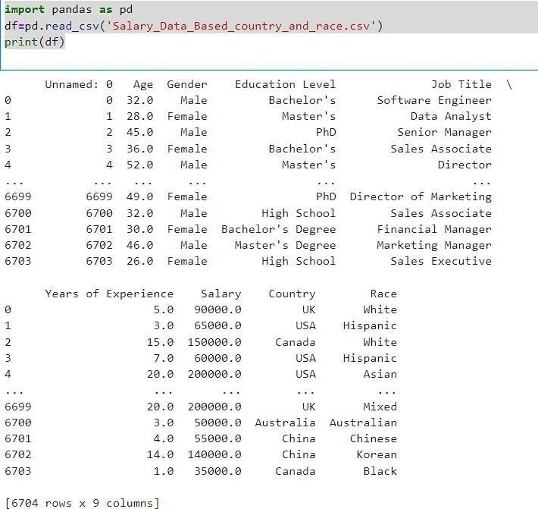)

* 1. To select first 5 rows of data df.head(5)

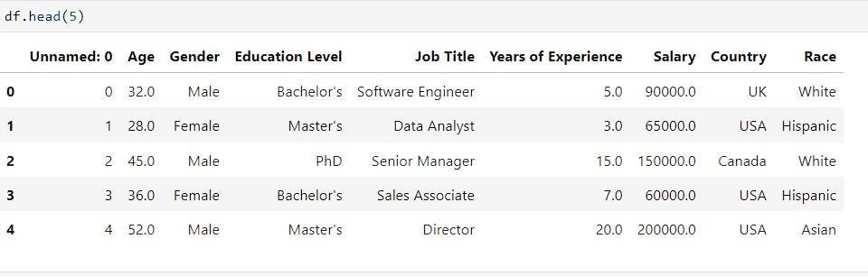

* 1. To select last 5 rows of data df.tail(5)

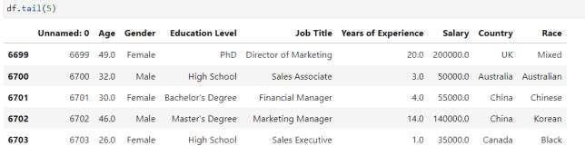

* 1. 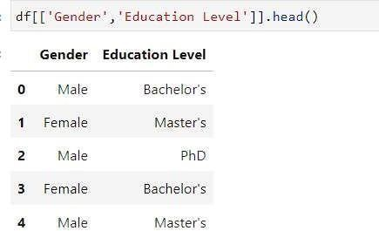Show first 5 rows of Gender and Education Level column df [['Gender', 'Education Level']].head()
  2. create a series from Gender = df ['Gender']

print("Data Type:",type(Gender)) select first 5 rows from a Gender. head()

